**3 Ways To Get Free Local Business Leads**

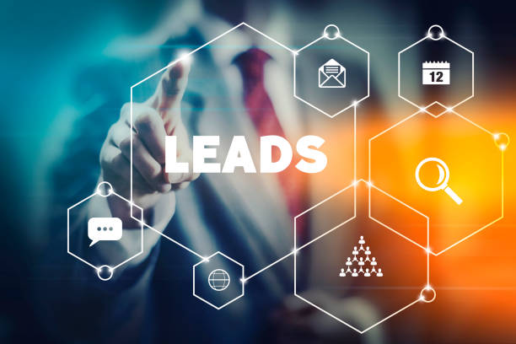

Now times have changed and people are searching information through the web whether from the comfort of their own homes and go with their mobiles device. Marketing a business by advertising on a company’s web is a critical component.

In digital marketing world, lead generation is the process of acquiring and engaging leads. Effective local lead generation strategies can help you do so. These strategies more targeted, they put your business in touch with your exact match.

Unqualified lead is not important while qualified lead is more important. You want to attract prospects that just can’t afford it, but also have a real need or desire for you goods and services.

For example, if you run a restaurant without have no local presence; your only customers bypass the local who needs quick meal. But you would lose all those internet benefits and might be visitors who visit in your restaurant because as well as we know that now days everyone like to find restaurant on the web.

Be it a large real estate company and a small hairdresser otherwise you and your competitors are detected.

Now small business standard changing and customers’ default approach to find a local business is to search for it on the web, research website and reviews on it.

Now most important the connection between customer’s expectation and the ability of the modern technology to meet that expectation has raised the bar for what a company to do to differentiate it from the crowd. If you choose free technology for your business growth in the digital marketing you can take information from [Digital Marketing Agency](https://www.digitalmathur.com/), who will help you optimize your business.

**Ways to get free business leads**

**Advertise on Facebook groups**



Now time Facebook used by 1.5 billion people every day. Because of popularity of the sites most of the companies participate and what better ways to introduce your goals and services to a massive audience than through social media?

As social media becomes more popular for business. Through social media business’ owner promote their own products and services by advertising.

Joining relevant local Facebook groups is an effective way to reach new audiences. Make sure you provide important information. The goal of this organization is to show audience how you can help them.

You can develop real connections with residents and giving value to those who wants your information. Through this you can increase trust of your audience. This trust helps you increasing your ROI.

**Email your current customers**



Referral marketing is easy way to increase lead generation. Most of the company use referral marketing strategy such as paypal, uber and airbnb for increase the number of visitors on their website.

You have think like large company such as uber. The users will reward with free rides for referring friends.

The goal of this email marketing is generating more leads. Your email sales leads are foundation of your email marketing. If properly follow email marketing then you will get better result in ROI.

**Optimize Google my business**

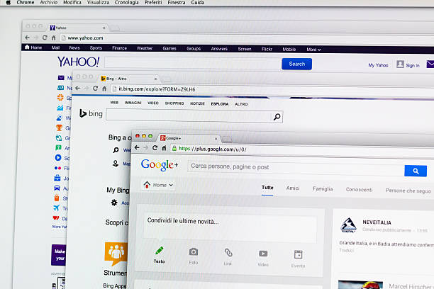

Google provide optimize Google my business to help business and organizations manage their online presence. It benefits to both customers and business. Customers can easily find out your business and businesses easily showcase their own brand and services through online presence. Businesses also check and update their information regarding services and brand.

Google my business allows companies to list their location on google map and local search result. Businesses also showcase their information such as link to your website, hours of operation and contact information.